**LAPORAN TUGAS BESAR**

**PEMROGRAMAN MOBILE**

**APLIKASI PENCATATAN KEUANGAN**

**“MyCoin”**

**DISUSUN OLEH :**

**AHMAD JIDAN FAHRIZAL**

**1809075018**



**PROGRAM STUDI TEKNIK ELEKTRO**

**FAKULTAS TEKNIK**

**UNIVERSITAS MULAWARMAN**

**SAMARINDA**

**2021**

## DAFTAR ISI

**DAFTAR ISI ii**

**Daftar Gambar iii**

**BAB I 1**

**PENDAHULUAN 1**

**1. 1 Latar Belakang 1**

**1. 2 Rumusan Masalah Manfaat 2**

**1. 3 Tujuan Pembuatan Aplikasi Android 2**

**1. 4 Manfaat 2**

**BAB II 3**

**LANDASAN TEORI 3**

**2. 1 RecyclerView 3**

**2. 2 Floating Action Button 3**

**2. 3 SQL Database 4**

**BAB III 5**

**PERANCANGAN APLIKASI 5**

**3. 1 Perancangan Sistem 5**

**3. 2 Perancangan UI/UX 7**

**3. 3 Coding 7**

**3. 4 Testing 39**

**3. 5 Debuging 46**

**BAB IV 47**

**KESIMPULAN DAN SARAN 47**

**4. 1 Kesimpulan 47**

**4. 2 Saran 47**

## Daftar Gambar

**Gambar 3. 1 Tampilan splash screen program** 39

**Gambar 3. 2 Tampilan pengenalan aplikasi** 40

**Gambar 3. 3 Tampilan utama halaman riwayat** 40

**Gambar 3. 4 Tampilan utama halaman hutang** 41

**Gambar 3. 5 Tampilan tambah catatan pemasukan halaman riwayat** 41

**Gambar 3. 6 Tampilan setelah klik simpan** 42

**Gambar 3. 7 Tampilan tambah catatan pengeluaran halaman hutang** 42

**Gambar 3. 8 Tampilan setelah klik simpan** 43

**Gambar 3. 9 Tampilan tambah catatan hutang** 43

**Gambar 3. 10 Tampilan setelah klik simpan** 44

**Gambar 3. 11 Tampilan setelah klik report** 44

**Gambar 3. 12 Tampilan setelah klik reset** 45

**Gambar 3. 13 Tampilan setelah klik yes** 45

## BAB I

## PENDAHULUAN

### 1. Latar Belakang

Pada umumnya kebanyakan orang membuat sebuah daftar list catatan keuangan mandiri masih dibuat dengan cara manual, yaitu mencatatkan daftar keuangan yang akan kita lakukan pada sebuah kertas berupa bentuk fisik. Mengapa penting membuat catatan keuangan mandiri? sesuatu yang besar biasanya harus dimulai dari kebiasaan kecil yang terlihat sederhana namun berdampak cukup banyak jika dilakukan dengan baik. Salah satu contohnya adalah kebiasaan membuat catatan keuangan mandiri untuk mengatur keuangan. Secara teori mungkin kita sudah tahu dan pernah melakukan hal ini, namun karena merasa sibuk dan terburu kadang kita lupa dan tidak disiplin dalam melakukannya. Selain itu anggapan bahwa hal ini tidak terlalu penting menjadi faktor pendukung untuk tidak membuat catatan keuangan tersebut. Namun jika kita melihat manfaat yang didapat dengan membuat catatan keuangan yang baik, mungkin kita bisa mempertimbangkan kembali untuk lebih rajin dan sadar akan pentingnya membuat catatan keuangan. Manfaat utama dari membuat catatan keuangan adalah membantu kita berpikir dalam mengeluarkan uang kita. Kita harus ingat jika pengeluaran keuangan kita melebihi pemasukan dan melihat untuk apa pengeluaran tersebut memang diperlukan atau tidak maka kita dapat berpikir bahwa pengeluaran apa saja yang diperlukan. Pengecekan waktu juga dilakukan secara manual sehingga menjadi kurang efektif terutama untuk banyak aktivitas yang telah terjadi bila melihat dengan kertas/buku tulis. Cara lain adalah dengan menggunakan perangkat lunak pada PC. Namun cara ini masih mempunyai kekurangan karna kita harus tetap berada pada PC tempat kita menyimpan task list tersebut untuk mengeceknya. Oleh karena itu dibuatlah sebuah aplikasi yang dapat menyediakan kemudahan pengelolaan keuangan secara mandiri seperti kemudahan menuliskan pada sebuah kertas yang dapat di akses lewat smartphone kita tanpa takut kehilangan bukti fisik catatan kita.

### 1. Rumusan Masalah Manfaat

Untuk Penelitian ini akan dibatasi pada hal-hal berikut:

1. Memaparkan pembuatan sistem aplikasi Android yang bisa berjalan di sistem operasi Android.
2. Versi Android yang digunakan yaitu Android versi 4.0 (KitKat) sampai Android 11.1(R).
3. Aplikasi dapat berjalan dalam kondisi offline maupun online

### 1. Tujuan Pembuatan Aplikasi Android

Tujuan dari penelitian ini adalah untuk merancang dan membuat aplikasi pencatatan keuangan secara mandiri yang dapat berjalan pada sistem operasi Android sehingga memberikan kemudahan bagi pemakainya dalam mengatur keuangan.

### 1. Manfaat

1. Mempermudah user dalam mengakses aplikasi karena menggunakan system operasi android
2. Membantu user dalam membuat pencatatan keuangan secara mandiri.

## BAB II

## LANDASAN TEORI

### 2. RecyclerView

RecyclerView adalah tampilan yang menggunakan arsitektur yang disederhanakan dengan UI Controller, Viewodel, dan LiveData. Menampilkan list atay grid data adalah salah satu tugas UI paling umum di Android. Daftar bervariasi dari yang sederhana hingga yang sangat kompleks. Daftar tampilan teks mungkin menampilkan data sederhana, seperti daftar belanja. Daftar yang kompleks, seperti daftar tujuan liburan yang beranotasi, dapat menunjukkan kepada pengguna banyak detail di dalam scrolling grid dengan header. Untuk mendukung semua kasus penggunaan ini, Android menyediakan widget RecyclerView. Manfaat terbesar dari RecyclerView adalah sangat efisien untuk daftar besar: Secara default, RecyclerView hanya berfungsi untuk memproses atau menggambar item yang saat ini terlihat di layer. Misalnya, jika list memiliki seribu elemen tetapi hanya 10 elemen yang terlihat, RecyclerView hanya berfungsi untuk menggambar 10 item di layer. Ketika pengguna melakukan scroll, RecyclerView mengetahui item baru apa yang seharusnya ada di layer dan tidak cukup berfungsi untuk menmpilkan item itu. Ketika suatu item scroll dari layer, tampilan item tersebut didaur ulang. Itu berarti item diisi dengan konten baru yng scroll ke layer. Perilaku RecyclerView ini menghemat banyak waktu pemrosesan dan membantu scroll list dengan lancar. Ketika suatu item berubah, alih-alih menggambar ulang seluruh daftar, RecyclerView dapat memperbarui satu item itu. Ini adalah keuntungan efisiensi yang sangat besar Ketika menampilkan daftar item kompleks.

### 2. Floating Action Button

Floating Action Button (FAB) adalah salah satu komponen dari Material Desain. FAB merupakan sebuah tombol yang berbentuk lingkaran dan ditampilkan seperti melayang pada aplikasi android.

### 2. SQL Database

Database SQLite adalah solusi penyimpanan yang baik jika anda memiliki data terstruktur yang perlu diakses dan disimpan secara persisten serta sering ditelusuri dan diubah. Anda juga bisa menggunakan SQLite sebagai media penyimpanan utama untuk data aplikasi atau pengguna, atau anda juga bisa menggunakannya untuk proses caching serta menyediakan data yang diambil dari cloud.

Jika anda bisa menyatakan data berupa baris dan kolom, pertimbangkan untuk memakai database SQLite. Jika anda menggunakan database SQLite, yang dinyatakan sebagai objek SQLiteDatabase adalah semua interaksi dengan database adalah melalui instance dari kelas SQLiteOpenHelper yang akan mengeksekusi permintaan dan pengelolaan database. Aplikasi anda hanya boleh berinteraksi dengan SQLiteOpenHelper, yang akan kita bahas bersama-sama dibawah ini.

Singktnya SQLite Database memiliki metode untuk membuat, menghapus, menjalankan perintah SQL, dan melakukan tugas manajemen database umum lainnya. seperti perintah CRUD (Create, Read, Update, Delete) data pada sebuah aplikasi catatan sederhana.

## BAB III

## PERANCANGAN APLIKASI

### 3. Perancangan Sistem

* Spesifikasi Minimum

Aplikasi Pengingat Tugas ini dapat berjalan dengan spek minimum Android versi 4.0 (KitKat)

* Flowchart

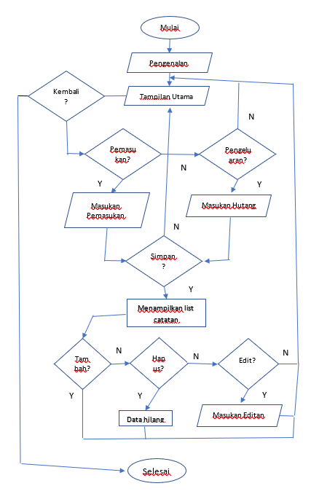

y

* Class Diagram

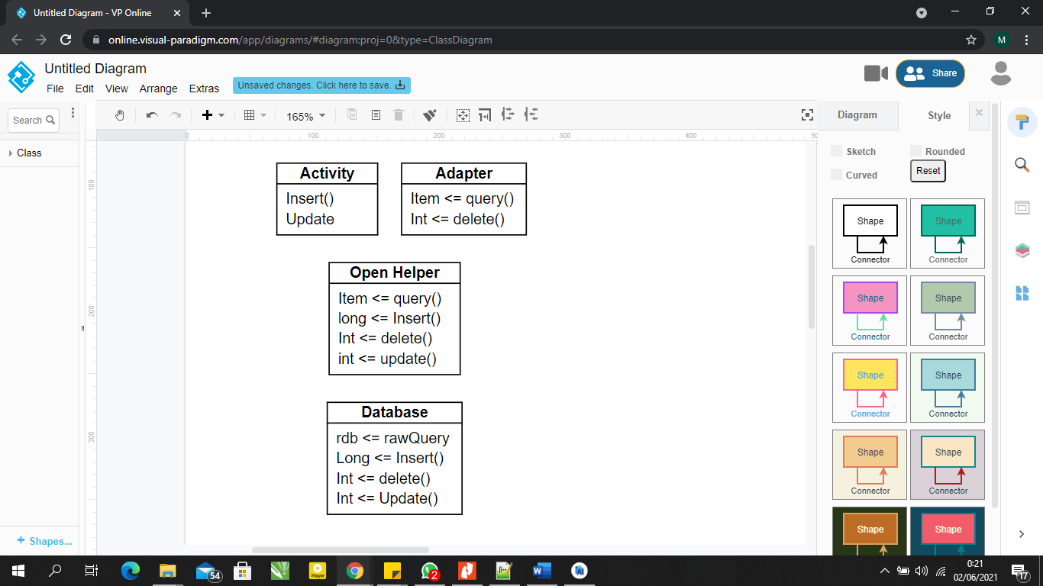

* Entity Relationship Diagram

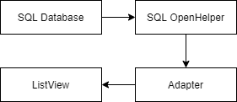

### 3. Perancangan UI/UX

* Component

Component yang digunakan dalam aplikasi ini ada recycleview, floating action button, spinner, text view, image button, progress bar, textview, imageview, check box.

* Layout

Layout yang digunakan dalam aplikasi ini relative layout, constrain layout, linear layout, dan fragment.

* Style

Style yang digunakan dalam aplikasi ini Theme.MaterialComponents.DayNight.NoActionBar .

### 3. Coding

* activity_main.xml

import android.Manifest  
import android.content.Intent  
import android.content.pm.PackageManager  
import android.os.Bundle  
import android.os.Environment  
import android.view.Menu  
import android.view.MenuItem  
import android.widget.Toast  
import androidx.appcompat.app.ActionBarDrawerToggle  
  
import androidx.appcompat.app.AlertDialog  
import androidx.appcompat.app.AppCompatActivity  
import androidx.core.app.ActivityCompat  
import androidx.core.content.ContextCompat  
import androidx.lifecycle.ViewModelProvider  
import com.ajts.androidmads.library.SQLiteToExcel  
import com.pm.mycoin.R  
import com.pm.mycoin.databinding.ActivityMainBinding  
import com.pm.mycoin.databinding.SaldoDialogLayoutBinding  
import com.pm.mycoin.utils.CurencyFormatter  
  
import com.pm.mycoin.view.fragment.main.MainFragment  
import com.pm.mycoin.view.fragment.main.MainViewModel  
  
class MainActivity : AppCompatActivity() {  
 private lateinit var binding: ActivityMainBinding  
 private lateinit var viewModel: MainViewModel  
 private lateinit var excelConverter: SQLiteToExcel  
  
 private val directoryPath =  
 Environment.getExternalStoragePublicDirectory(Environment.*DIRECTORY_DOWNLOADS*).*path* private val tableList = *arrayListOf*("record_table", "debt_table")  
 private var permissionGranted = false  
 private var alreadyConverted = false  
  
 private var totalExpenses = 0L  
 private var totalIncome = 0L  
 private var totalDebt = 0L  
  
 override fun onCreate(savedInstanceState: Bundle?) {  
  
 super.onCreate(savedInstanceState)  
 binding = ActivityMainBinding.inflate(*layoutInflater*)  
 setContentView(binding.*root*)  
 setSupportActionBar(binding.mainToolbar)  
 *supportActionBar*?.*title* = null  
  
 ActivityCompat.requestPermissions(  
 this,  
 *arrayOf*(Manifest.permission.*WRITE_EXTERNAL_STORAGE*),  
 1  
 )  
  
  
 val toggle = ActionBarDrawerToggle(  
 this, binding.drawerLayout,  
 R.string.*open*,  
 R.string.*close* )  
 binding.drawerLayout.addDrawerListener(toggle)  
 toggle.syncState()  
 toggle.*isDrawerIndicatorEnabled* = true  
 toggle.*drawerArrowDrawable*.*color* = ContextCompat.getColor(this, android.R.color.*white*)  
  
  
  
  
 *supportFragmentManager*.beginTransaction().replace(R.id.*fragment*, MainFragment()).commit()  
  
 viewModel = ViewModelProvider(this).get(MainViewModel::class.*java*)  
 viewModel.getTotalExpenses()?.observe(this, **{** if (**it** != null) {  
 totalExpenses = **it**.toLong()  
 }  
 **}**)  
  
 viewModel.getTotalIncome()?.observe(this, **{** if (**it** != null) {  
 totalIncome = **it**.toLong()  
 }  
 **}**)  
  
 viewModel.getTotalDebt()?.observe(this, **{** if (**it** != null) {  
 totalDebt = **it**.toLong()  
 }  
 **}**)  
 }  
  
 override fun onRequestPermissionsResult(  
 requestCode: Int,  
 permissions: Array<out String>,  
 grantResults: IntArray  
 ) {  
 when (requestCode) {  
 1 -> if (grantResults.*isNotEmpty*() && grantResults[0] == PackageManager.*PERMISSION_GRANTED*) {  
 permissionGranted = true  
 }  
 }  
 }  
  
 override fun onCreateOptionsMenu(menu: Menu): Boolean {  
 *menuInflater*.inflate(R.menu.*main*, menu)  
 return true  
 }  
  
 override fun onOptionsItemSelected(item: MenuItem): Boolean {  
 when (item.*itemId*) {  
 R.id.*action_reset* -> showDialog()  
 R.id.*action_saldo* -> showBalanceDialog()  
  
 }  
  
 return true  
 }  
  
  
  
 private fun showBalanceDialog() {  
 val dialog = AlertDialog.Builder(this)  
 val dialogView = SaldoDialogLayoutBinding.inflate(*layoutInflater*)  
  
 dialogView.*apply* **{** dialogMainIncome.*text* = CurencyFormatter.convertAndFormat(totalIncome)  
 dialogMainExpenses.*text* = CurencyFormatter.convertAndFormat(  
 totalExpenses  
 )  
 dialogMainDebt.*text* = CurencyFormatter.convertAndFormat(totalDebt)  
 dialogMainSaldo.*text* =  
 CurencyFormatter.convertAndFormat(totalIncome - (totalExpenses + totalDebt))  
 **}** dialog.setView(dialogView.*root*)  
 dialog.setTitle(R.string.*dialog_title_saldo*)  
 dialog.setCancelable(true)  
 dialog.setPositiveButton("Close", null)  
 dialog.show()  
 }  
  
 private fun showDialog() {  
 val dialog = AlertDialog.Builder(this)  
 dialog.setTitle(getString(R.string.*perhatian*))  
 dialog.setMessage(R.string.*dialog_message*)  
 dialog.setCancelable(true)  
 dialog.setPositiveButton("Yes") **{** _, _ **->** viewModel.deleteAllRecord()  
 viewModel.deleteAllDebt()  
  
 totalIncome = 0  
 totalExpenses = 0  
 totalDebt = 0  
 **}** dialog.setNegativeButton("Cancel") **{** innerDialog, _ **->** innerDialog.dismiss()  
 **}** dialog.show()  
 }  
  
 fun reduceValue(key: String, amount: Long) {  
 when (key) {  
 "income" -> totalIncome -= amount  
 "expenses" -> totalExpenses -= amount  
 else -> totalDebt -= amount  
 }  
 }  
  
}

* **Intro1activity**

import android.content.Intent  
import androidx.appcompat.app.AppCompatActivity  
import android.os.Bundle  
import android.widget.Button  
import android.widget.ImageButton  
import com.pm.mycoin.R  
  
class Intro1Activity : AppCompatActivity() {  
 override fun onCreate(savedInstanceState: Bundle?) {  
 super.onCreate(savedInstanceState)  
 setContentView(R.layout.*activity_intro1*)  
 val btnnext = findViewById<Button>(R.id.*btnnext*)  
  
 btnnext?.setOnClickListener **{** startActivity(Intent(this, MainActivity::class.*java*))  
 **}** }  
}

* **SplashScreenActivity**

import android.content.Intent  
import androidx.appcompat.app.AppCompatActivity  
import android.os.Bundle  
import android.os.Handler  
import com.pm.mycoin.R  
  
class SplashScreenActivity : AppCompatActivity() {  
 private val SPLASH_TIME_OUT:Long = 3000  
 override fun onCreate(savedInstanceState: Bundle?) {  
 super.onCreate(savedInstanceState)  
 setContentView(R.layout.*activity_splash_screen*)  
 Handler().postDelayed(**{** startActivity(Intent(this,Intro1Activity::class.*java*))  
 finish()  
 **}**, SPLASH_TIME_OUT)  
  
  
 }  
}

* **MainFragment**

import android.annotation.SuppressLint  
import android.app.DatePickerDialog  
import android.os.Bundle  
import android.view.LayoutInflater  
import android.view.View  
import android.view.ViewGroup  
import android.widget.Toast  
import androidx.appcompat.app.AlertDialog  
import androidx.fragment.app.Fragment  
import androidx.lifecycle.ViewModelProvider  
import androidx.viewpager.widget.ViewPager  
import com.pm.mycoin.R  
import com.pm.mycoin.databinding.AddDialogLayoutBinding  
import com.pm.mycoin.databinding.FragmentMainBinding  
import com.pm.mycoin.db.Debt  
import com.pm.mycoin.db.Record  
import com.pm.mycoin.utils.CurencyFormatter  
import com.pm.mycoin.utils.DateUtil  
import java.util.*  
  
class MainFragment : Fragment() {  
 private lateinit var binding: FragmentMainBinding  
 private lateinit var viewModel: MainViewModel  
 private lateinit var adapter: PagerAdapter  
  
 override fun onCreateView(  
 inflater: LayoutInflater, container: ViewGroup?,  
 savedInstanceState: Bundle?  
 ): View {  
 binding = FragmentMainBinding.inflate(inflater, container, false)  
 return binding.root  
 }  
  
 override fun onViewCreated(view: View, savedInstanceState: Bundle?) {  
 super.onViewCreated(view, savedInstanceState)  
  
 viewModel = ViewModelProvider(this).get(MainViewModel::class.*java*)  
 viewModel.getTotalExpenses()?.observe(*viewLifecycleOwner*, **{** if (**it** != null) {  
 binding.mainTotalExpenses.text = CurencyFormatter.convertAndFormat(**it**.toLong())  
 } else {  
 binding.mainTotalExpenses.text = CurencyFormatter.convertAndFormat(0)  
 }  
 **}**)  
  
 viewModel.getTotalIncome()?.observe(*viewLifecycleOwner*, **{** if (**it** != null) {  
 binding.mainTotalIncome.text = CurencyFormatter.convertAndFormat(**it**.toLong())  
 } else {  
 binding.mainTotalIncome.text = CurencyFormatter.convertAndFormat(0)  
 }  
 **}**)  
  
 adapter = PagerAdapter(*childFragmentManager*)  
 binding.apply **{** mainViewPager.adapter = adapter  
 mainViewPager.offscreenPageLimit = 3  
 mainViewPager.addOnPageChangeListener(object : ViewPager.OnPageChangeListener {  
 override fun onPageScrollStateChanged(p0: Int) {}  
  
 override fun onPageScrolled(p0: Int, p1: Float, p2: Int) {  
 if (p0 == 1) {  
 historyFab.hide()  
 debtFab.show()  
 } else {  
 historyFab.show()  
 debtFab.hide()  
 }  
 }  
  
 override fun onPageSelected(p0: Int) {  
 if (p0 == 0) {  
 historyFab.hide()  
 debtFab.show()  
 } else {  
 historyFab.show()  
 debtFab.hide()  
 }  
 }  
 })  
  
 binding.mainTabLayout.setupWithViewPager(mainViewPager)  
  
 historyFab.setOnClickListener **{** showAddDataDialog("history") **}** debtFab.setOnClickListener **{** showAddDataDialog("utang") **}  
 }** }  
  
 @SuppressLint("SetTextI18n")  
 private fun showAddDataDialog(key: String) {  
 val builder = *context*?.*let* **{** AlertDialog.Builder(**it**) **}** val dialogView = AddDialogLayoutBinding.inflate(*layoutInflater*)  
  
 var selectedDate = Date()  
 val c = Calendar.getInstance()  
 val year = c.get(Calendar.*YEAR*)  
 val month = c.get(Calendar.*MONTH*)  
 val day = c.get(Calendar.*DAY_OF_MONTH*)  
  
 when (key) {  
 "utang" -> dialogView.dialogCheckboxIncome.visibility = View.*GONE* }  
  
 builder?.setView(dialogView.root)  
 dialogView.dialogShowDate.setOnClickListener **{** DatePickerDialog(requireContext(), **{** _, year, monthOfYear, dayOfMonth **->** val calendar = Calendar.getInstance()  
 calendar.set(year, monthOfYear, dayOfMonth)  
 dialogView.dialogDate.text =  
 "Transaction date: ${DateUtil.formatDate(calendar.*time*)}"  
 selectedDate = calendar.*time* **}**, year, month, day).show()  
 **}** builder?.setCancelable(true)  
 builder?.setPositiveButton(R.string.*dialog_simpan*, null)  
 val dialog = builder?.create()  
 dialog?.show()  
 dialog?.getButton(AlertDialog.*BUTTON_POSITIVE*)?.setOnClickListener **{** val isIncome = if (dialogView.dialogCheckboxIncome.isChecked) {  
 "income"  
 } else {  
 "expenses"  
 }  
  
 if (dialogView.dialogTitle.text.isNotBlank() && dialogView.dialogAmount.text.isNotBlank()  
 ) {  
  
 val totalIncome = dialogView.dialogAmount.text.toString()  
  
 if (key == "history") {  
 val record = Record(  
 0,  
 dialogView.dialogTitle.text.toString(),  
 totalIncome.toLong(),  
 selectedDate,  
 isIncome  
 )  
  
 viewModel.insertRecord(record)  
 } else {  
 val debt = Debt(  
 0,  
 dialogView.dialogTitle.text.toString(),  
 totalIncome.toInt(),  
 selectedDate  
 )  
  
 viewModel.insertDebt(debt)  
 }  
  
 dialog.dismiss()  
 } else {  
 Toast.makeText(*context*, R.string.*toast_isi_kolom*, Toast.*LENGTH_SHORT*).show()  
 }  
 **}** }  
}

* **MainViewModel**

import android.app.Application  
import androidx.lifecycle.AndroidViewModel  
import androidx.lifecycle.LiveData  
import com.pm.mycoin.db.Debt  
import com.pm.mycoin.db.DebtRepo  
import com.pm.mycoin.db.Record  
import com.pm.mycoin.db.RecordRepo  
import com.pm.mycoin.utils.DateUtil  
import java.util.*  
  
class MainViewModel(application: Application) : AndroidViewModel(application) {  
 private val recordRepo = RecordRepo(application)  
 private val debtRepo = DebtRepo(application)  
  
 fun getAllRecords(isNewest: Boolean): LiveData<List<Record>>? {  
 return if (isNewest) {  
 recordRepo.getAllRecordsDesc()  
 } else {  
 recordRepo.getAllRecordsAsc()  
 }  
 }  
  
 fun getFilteredRecord(  
 startDate: Date,  
 endDate: Date,  
 isDesc: Boolean  
 ): LiveData<List<Record>>? =  
 recordRepo.getFilteredRecord(DateUtil.subtractDays(startDate, 1), endDate, isDesc)  
  
 fun getAllDebts(isNewest: Boolean): LiveData<List<Debt>>? {  
 return if (isNewest) {  
 debtRepo.getAllDebtDesc()  
 } else {  
 debtRepo.getAllDebtAsc()  
 }  
 }  
  
 fun getFilteredDebt(startDate: Date, endDate: Date, isDesc: Boolean): LiveData<List<Debt>>? =  
 debtRepo.getFilteredDebtDesc(DateUtil.subtractDays(startDate, 1), endDate, isDesc)  
  
 fun getTotalExpenses(): LiveData<Int>? {  
 return recordRepo.getTotalExpenses()  
 }  
  
 fun getTotalDebt(): LiveData<Int>? {  
 return debtRepo.getTotalDebt()  
 }  
  
 fun getTotalIncome(): LiveData<Int>? {  
 return recordRepo.getTotalIncome()  
 }  
  
 fun insertRecord(record: Record) {  
 recordRepo.insertRecord(record)  
 }  
  
 fun updateRecord(record: Record) {  
 recordRepo.updateRecord(record)  
 }  
  
 fun insertDebt(debt: Debt) {  
 return debtRepo.insertDebt(debt)  
 }  
  
 fun deleteRecord(record: Record) {  
 recordRepo.deleteRecord(record)  
 }  
  
 fun deleteDebt(debt: Debt) {  
 debtRepo.deleteDebt(debt)  
 }  
  
 fun updateDebt(debt: Debt) {  
 debtRepo.updateDebt(debt)  
 }  
  
 fun deleteAllRecord() {  
 recordRepo.deleteAllRecord()  
 }  
  
 fun deleteAllDebt() {  
 debtRepo.deleteAllDebt()  
 }

* **PagerAdapter**

import androidx.fragment.app.Fragment  
import androidx.fragment.app.FragmentManager  
import androidx.fragment.app.FragmentStatePagerAdapter  
import com.pm.mycoin.view.fragment.debt.DebtFragment  
import com.pm.mycoin.view.fragment.history.HistoryFragment  
  
class PagerAdapter(fragmentManager: FragmentManager) :  
 FragmentStatePagerAdapter(fragmentManager, *BEHAVIOR_RESUME_ONLY_CURRENT_FRAGMENT*) {  
  
 private val fragments = *listOf*(HistoryFragment(), DebtFragment())  
  
 override fun getItem(p0: Int): Fragment = fragments[p0]  
  
 override fun getCount(): Int = fragments.size  
  
 override fun getPageTitle(position: Int): CharSequence? {  
 return when (position) {  
 0 -> "RIWAYAT"  
 1 -> "HUTANG"  
 else -> super.getPageTitle(position)  
 }  
 }  
}

* **Debt**

import androidx.annotation.NonNull  
import androidx.room.*  
import com.pm.mycoin.db.converter.DateConverter  
import java.util.*  
  
@Entity(tableName = "record_table")  
@TypeConverters(DateConverter::class)  
class Record(  
 @PrimaryKey(autoGenerate = true)  
 @NonNull  
 @ColumnInfo(name = "id")  
 var id: Int = 0,  
 @ColumnInfo(name = "judul")  
 var judul: String = "None",  
 @ColumnInfo(name = "total")  
 var total: Long = 0,  
 @ColumnInfo(name = "date")  
 var date: Date? = null,  
 @ColumnInfo(name = "description")  
 var description: String = "expenses",  
 @Ignore  
 var type: Int = 0  
)  
  
@Entity(tableName = "debt_table")  
@TypeConverters(DateConverter::class)  
class Debt(  
 @PrimaryKey(autoGenerate = true)  
 @NonNull  
 @ColumnInfo(name = "id")  
 var id: Int = 0,  
 @ColumnInfo(name = "judul")  
 var judul: String = "None",  
 @ColumnInfo(name = "total")  
 var total: Int = 0,  
 @ColumnInfo(name = "date")  
 var date: Date? = null,  
 @Ignore  
 var type: Int = 0  
)

* **DebtAdapter**

import android.view.LayoutInflater  
import android.view.ViewGroup  
import androidx.recyclerview.widget.RecyclerView  
import androidx.viewbinding.ViewBinding  
import com.pm.mycoin.databinding.ItemDateBinding  
import com.pm.mycoin.databinding.ItemRowBinding  
import com.pm.mycoin.db.Debt  
import com.pm.mycoin.utils.CurencyFormatter.convertAndFormat  
import com.pm.mycoin.utils.DateUtil  
import java.util.*  
  
class DebtAdapter(  
 private var datas: MutableList<Debt>?,  
 private val clickUtils: (Debt, String) -> Unit  
) : RecyclerView.Adapter<RecyclerView.ViewHolder>() {  
 var date: Date? = null  
 override fun getItemViewType(position: Int): Int {  
 if (datas != null) {  
 return datas!![position].type  
 }  
  
 return 0  
 }  
  
 override fun onCreateViewHolder(p0: ViewGroup, p1: Int): RecyclerView.ViewHolder {  
 val inflater = LayoutInflater.from(p0.*context*)  
 val binding: ViewBinding  
  
 if (p1 == 0) {  
 binding = ItemRowBinding.inflate(inflater, p0, false)  
 return MainHolder(binding)  
 }  
  
 binding = ItemDateBinding.inflate(inflater, p0, false)  
 return DateHolder(binding)  
 }  
  
 override fun getItemCount(): Int {  
 return datas?.size ?: 0  
 }  
  
 override fun onBindViewHolder(p0: RecyclerView.ViewHolder, p1: Int) {  
 if (datas != null) {  
 if (p0.*itemViewType* == 0) {  
 p0 as DebtAdapter.MainHolder  
 p0.bind(datas!![p1], clickUtils)  
 } else {  
 p0 as DebtAdapter.DateHolder  
 p0.bind(datas!![p1].date!!)  
 }  
 }  
 }  
  
 fun setData(debt: MutableList<Debt>?) {  
 if (debt == null || debt.isEmpty()) {  
 datas?.clear()  
 } else {  
 var date = DateUtil.formatDate(debt[0].date!!)  
 debt.add(0, Debt(type = 1, date = debt[0].date))  
  
 var i = 0  
 while (i <= debt.size - 1) {  
 val formattedDate = DateUtil.formatDate(debt[i].date!!)  
  
 if (date != formattedDate) {  
 date = formattedDate  
 debt.add(i, Debt(type = 1, date = debt[i].date))  
 } else {  
 i++  
 }  
 }  
  
 datas = debt  
 }  
 notifyDataSetChanged()  
 }  
  
 inner class MainHolder(private val binding: ItemRowBinding) :  
 RecyclerView.ViewHolder(binding.*root*) {  
 private lateinit var debt: Debt  
  
 fun bind(debt: Debt, clickUtils: (Debt, String) -> Unit) {  
 this.debt = debt  
  
 binding.*apply* **{** itemTitle.*text* = debt.judul  
 itemUang.*text* = convertAndFormat(debt.total.toLong())  
// itemDate.text = DateUtil.formatDate(debt.date!!)  
 itemDelete.setOnClickListener **{** clickUtils(debt, "delete") **}** itemUpdate.setOnClickListener **{** clickUtils(debt, "edit") **}** itemView.setOnClickListener **{** clickUtils(debt, "edit") **}  
 }** }  
 }  
  
 inner class DateHolder(private val binding: ItemDateBinding) :  
 RecyclerView.ViewHolder(binding.*root*) {  
 fun bind(date: Date) {  
 binding.itemDate.*text* = DateUtil.formatDate(date)  
 }  
 }  
}

* **DebtFragment**

import android.annotation.SuppressLint  
import android.app.DatePickerDialog  
import android.os.Bundle  
import android.view.LayoutInflater  
import android.view.View  
import android.view.ViewGroup  
import android.widget.Toast  
import androidx.appcompat.app.AlertDialog  
import androidx.fragment.app.Fragment  
import androidx.lifecycle.ViewModelProvider  
import androidx.recyclerview.widget.LinearLayoutManager  
import com.pm.mycoin.R  
import com.pm.mycoin.databinding.AddDialogLayoutBinding  
import com.pm.mycoin.databinding.FilterDialogLayoutBinding  
import com.pm.mycoin.databinding.FragmentDebtBinding  
import com.pm.mycoin.db.Debt  
import com.pm.mycoin.utils.DateUtil  
import com.pm.mycoin.view.activity.main.MainActivity  
import com.pm.mycoin.view.fragment.main.MainViewModel  
import java.util.*  
  
class DebtFragment : Fragment() {  
 private lateinit var binding: FragmentDebtBinding  
 private var adapter: DebtAdapter? = null  
 private var viewModel: MainViewModel? = null  
 private var debts: List<Debt>? = null  
  
 private var startDate: Date? = null  
 private var endDate: Date? = null  
  
 private var isNewest = true  
 private var isFiltered = false  
  
 override fun onCreateView(  
 inflater: LayoutInflater,  
 container: ViewGroup?,  
 savedInstanceState: Bundle?  
 ): View {  
 binding = FragmentDebtBinding.inflate(inflater, container, false)  
 return binding.*root* }  
  
 override fun onViewCreated(view: View, savedInstanceState: Bundle?) {  
 super.onViewCreated(view, savedInstanceState)  
 viewModel = *activity*?.*let* **{** ViewModelProvider(**it**).get(MainViewModel::class.*java*) **}** populateRecycler()  
 getAllDebts()  
  
 binding.debtSort.setOnClickListener **{** isNewest = !isNewest  
  
 debts = debts?.*reversed*()  
 adapter?.setData(debts?.*toMutableList*())  
  
 if (!isNewest) binding.debtSortImage.*rotationX* = 180.0.toFloat()  
 else binding.debtSortImage.*rotationX* = 0.toFloat()  
  
 if (!isNewest) binding.debtSortText.*text* = getString(R.string.*sort_oldest*)  
 else binding.debtSortText.*text* = getString(R.string.*sort_newest*)  
 **}** binding.debtFilter.setOnClickListener **{** if (isFiltered) {  
 binding.debtFilterText.*text* = getString(R.string.*filter*)  
 getAllDebts()  
 } else {  
 showFilterDialog()  
 }  
  
 isFiltered = !isFiltered  
 **}** }  
  
 private fun getAllDebts() {  
 viewModel?.getAllDebts(isNewest)?.observe(*viewLifecycleOwner*, **{** debts = **it** adapter?.setData(**it**?.*toMutableList*())  
 **}**)  
 }  
  
 private fun populateRecycler() {  
 adapter = DebtAdapter(null) **{** it, it1 **->** if (it1 == "delete") {  
 (*parentFragment*?.*activity* as MainActivity).reduceValue("", it.total.toLong())  
  
 viewModel?.deleteDebt(it)  
 Toast.makeText(*context*, R.string.*toast_hapus_berhasil*, Toast.*LENGTH_SHORT*).show()  
 } else {  
 showAddDataDialog(it)  
 }  
 **}** binding.debtRecycler.*apply* **{** *layoutManager* = LinearLayoutManager(*context*)  
 setHasFixedSize(true)  
 **}** binding.debtRecycler.*adapter* = adapter  
 }  
  
 @SuppressLint("SetTextI18n")  
 private fun showAddDataDialog(debt: Debt) {  
 val builder = *context*?.*let* **{** AlertDialog.Builder(**it**) **}** val dialogView = AddDialogLayoutBinding.inflate(*layoutInflater*)  
  
 dialogView.*apply* **{** dialogTitle.setText(debt.judul)  
 dialogAmount.setText(debt.total.toString())  
 dialogDate.*text* = "Transaction date: ${debt.date?.*let* **{** DateUtil.formatDate(**it**) **}**}"  
 dialogCheckboxIncome.*visibility* = View.*GONE* **}** var selectedDate = debt.date  
 val c = Calendar.getInstance()  
 val year = c.get(Calendar.*YEAR*)  
 val month = c.get(Calendar.*MONTH*)  
 val day = c.get(Calendar.*DAY_OF_MONTH*)  
  
 dialogView.dialogShowDate.setOnClickListener **{** DatePickerDialog(requireContext(), **{** _, year, monthOfYear, dayOfMonth **->** val calendar = Calendar.getInstance()  
 calendar.set(year, monthOfYear, dayOfMonth)  
 dialogView.dialogDate.*text* =  
 "Transaction date: ${DateUtil.formatDate(calendar.*time*)}"  
 selectedDate = calendar.*time* **}**, year, month, day).show()  
 **}** builder?.setView(dialogView.*root*)  
 builder?.setCancelable(true)  
 builder?.setPositiveButton(R.string.*dialog_simpan*, null)  
  
 val dialog = builder?.create()  
 dialog?.show()  
 dialog?.getButton(AlertDialog.*BUTTON_POSITIVE*)?.setOnClickListener **{** if (dialogView.dialogTitle.*text*.*isNotBlank*() && dialogView.dialogAmount.*text*.*isNotBlank*()  
 && selectedDate != null  
 ) {  
 val innerDebt = Debt(  
 debt.id, dialogView.dialogTitle.*text*.toString(),  
 dialogView.dialogAmount.*text*.toString().*toInt*(),  
 selectedDate  
 )  
  
 viewModel?.updateDebt(innerDebt)  
 dialog.dismiss()  
 } else {  
 Toast.makeText(*context*, R.string.*toast_isi_kolom*, Toast.*LENGTH_SHORT*).show()  
 }  
 **}** }  
  
 private fun showFilterDialog() {  
 val dialog = *context*?.*let* **{** AlertDialog.Builder(**it**) **}** val dialogView = FilterDialogLayoutBinding.inflate(*layoutInflater*)  
  
 val c = Calendar.getInstance()  
 val year = c.get(Calendar.*YEAR*)  
 val month = c.get(Calendar.*MONTH*)  
 val day = c.get(Calendar.*DAY_OF_MONTH*)  
  
 dialogView.filterStartDate.setOnClickListener **{** DatePickerDialog(requireContext(), **{** _, year, monthOfYear, dayOfMonth **->** val calendar = Calendar.getInstance()  
 calendar.set(year, monthOfYear, dayOfMonth)  
 startDate = calendar.*time* dialogView.filterStartDate.*text* = DateUtil.formatDate(calendar.*time*)  
 **}**, year, month, day).show()  
 **}** dialogView.filterEndDate.setOnClickListener **{** DatePickerDialog(requireContext(), **{** _, year, monthOfYear, dayOfMonth **->** val calendar = Calendar.getInstance()  
 calendar.set(year, monthOfYear, dayOfMonth)  
 endDate = calendar.*time* dialogView.filterEndDate.*text* = DateUtil.formatDate(calendar.*time*)  
 **}**, year, month, day).show()  
 **}** dialog?.setView(dialogView.*root*)  
 dialog?.setCancelable(true)  
 dialog?.setPositiveButton(R.string.*dialog_simpan*) **{** _, _ **->** if (startDate != null && endDate != null) {  
 viewModel?.getFilteredDebt(startDate!!, endDate!!, isNewest)  
 ?.observe(*viewLifecycleOwner*, **{** debts = **it** adapter?.setData(**it**?.*toMutableList*())  
  
 binding.debtFilterText.*text* = getString(R.string.*remove_filter*)  
 **}**)  
 }  
 **}** dialog?.show()  
 }  
}

* **HistoryAdapter**

import android.content.Context  
import android.view.LayoutInflater  
import android.view.View  
import android.view.ViewGroup  
import androidx.core.content.ContextCompat  
import androidx.recyclerview.widget.RecyclerView  
import androidx.viewbinding.ViewBinding  
import com.pm.mycoin.R  
import com.pm.mycoin.databinding.ItemDateBinding  
import com.pm.mycoin.databinding.ItemRowBinding  
import com.pm.mycoin.db.Record  
import com.pm.mycoin.utils.CurencyFormatter.convertAndFormat  
import com.pm.mycoin.utils.DateUtil  
import java.util.*  
  
class HistoryAdapter(  
 private val context: Context,  
 private var datas: MutableList<Record>?,  
 private val fromGraph: Boolean,  
 private val clickUtils: (Record, String) -> Unit,  
) : RecyclerView.Adapter<RecyclerView.ViewHolder>() {  
 var date: Date? = null  
 override fun getItemViewType(position: Int): Int {  
 if (datas != null) {  
 return datas!![position].type  
 }  
  
 return 0  
 }  
  
 override fun onCreateViewHolder(p0: ViewGroup, p1: Int): RecyclerView.ViewHolder {  
 val inflater = LayoutInflater.from(context)  
 val binding: ViewBinding  
  
 if (p1 == 0) {  
 binding = ItemRowBinding.inflate(inflater, p0, false)  
 return MainHolder(binding)  
 }  
  
 binding = ItemDateBinding.inflate(inflater, p0, false)  
 return DateHolder(binding)  
 }  
  
 override fun getItemCount(): Int {  
 return datas?.size ?: 0  
 }  
  
 override fun onBindViewHolder(p0: RecyclerView.ViewHolder, p1: Int) {  
 if (datas != null) {  
 if (p0.*itemViewType* == 0) {  
 p0 as MainHolder  
 p0.bind(datas!![p1], clickUtils)  
 } else {  
 p0 as DateHolder  
 p0.bind(datas!![p1].date!!)  
 }  
 }  
 }  
  
 fun setData(records: MutableList<Record>?) {  
 datas?.clear()  
  
 if (!records.*isNullOrEmpty*()) {  
 var date = DateUtil.formatDate(records[0].date!!)  
 records.add(0, Record(type = 1, date = records[0].date))  
  
 var i = 0  
 while (i <= records.size - 1) {  
 val formattedDate = DateUtil.formatDate(records[i].date!!)  
  
 if (date != formattedDate) {  
 date = formattedDate  
 records.add(i, Record(type = 1, date = records[i].date))  
 } else {  
 i++  
 }  
 }  
  
 datas = records  
 }  
  
 notifyDataSetChanged()  
 }  
  
 inner class MainHolder(private val binding: ItemRowBinding) :  
 RecyclerView.ViewHolder(binding.*root*) {  
 private lateinit var record: Record  
  
 fun bind(record: Record, clickUtils: (Record, String) -> Unit) {  
 this.record = record  
  
 binding.*apply* **{** itemTitle.*text* = record.judul  
 itemUang.*text* = convertAndFormat(record.total.toLong())  
 itemDelete.setOnClickListener **{** clickUtils(record, "delete") **}** itemUpdate.setOnClickListener **{** clickUtils(record, "edit") **}** itemView.setOnClickListener **{** clickUtils(record, "edit") **}** if (!fromGraph) {  
 itemDelete.setOnClickListener **{** clickUtils(record, "delete") **}** itemUpdate.setOnClickListener **{** clickUtils(record, "edit") **}** } else {  
 itemDelete.*visibility* = View.*GONE* itemUpdate.*visibility* = View.*GONE* }  
  
 if (record.description == "income") {  
 itemColor.setBackgroundColor(  
 ContextCompat.getColor(  
 context,  
 R.color.*colorAccent* )  
 )  
 itemUang.setTextColor(ContextCompat.getColor(context, R.color.*colorAccent*))  
 } else {  
 itemColor.setBackgroundColor(  
 ContextCompat.getColor(  
 context,  
 R.color.*colorRed* )  
 )  
 itemUang.setTextColor(ContextCompat.getColor(context, R.color.*colorRed*))  
 }  
 **}** }  
 }  
  
 inner class DateHolder(private val binding: ItemDateBinding) :  
 RecyclerView.ViewHolder(binding.*root*) {  
 fun bind(date: Date) {  
 binding.itemDate.*text* = DateUtil.formatDate(date)  
 }  
 }  
}

* **HistoryFragent**

import android.annotation.SuppressLint  
import android.app.DatePickerDialog  
import android.os.Bundle  
import android.view.LayoutInflater  
import android.view.View  
import android.view.ViewGroup  
import android.widget.Toast  
import androidx.appcompat.app.AlertDialog  
import androidx.fragment.app.Fragment  
import androidx.lifecycle.ViewModelProvider  
import androidx.recyclerview.widget.LinearLayoutManager  
import com.pm.mycoin.R  
import com.pm.mycoin.databinding.AddDialogLayoutBinding  
import com.pm.mycoin.databinding.FilterDialogLayoutBinding  
import com.pm.mycoin.databinding.FragmentHistoryBinding  
import com.pm.mycoin.db.Record  
import com.pm.mycoin.utils.DateUtil  
import com.pm.mycoin.view.activity.main.MainActivity  
import com.pm.mycoin.view.fragment.main.MainViewModel  
import java.util.*  
  
  
class HistoryFragment : Fragment() {  
 private lateinit var binding: FragmentHistoryBinding  
  
 private var viewModel: MainViewModel? = null  
 private var adapter: HistoryAdapter? = null  
 private var records: List<Record>? = null  
  
 private var startDate: Date? = null  
 private var endDate: Date? = null  
  
 private var isNewest = true  
 private var isFiltered = false  
  
 override fun onCreateView(  
 inflater: LayoutInflater,  
 container: ViewGroup?,  
 savedInstanceState: Bundle?  
 ): View {  
 binding = FragmentHistoryBinding.inflate(inflater, container, false)  
 return binding.*root* }  
  
 override fun onViewCreated(view: View, savedInstanceState: Bundle?) {  
 super.onViewCreated(view, savedInstanceState)  
 viewModel = *activity*?.*let* **{** ViewModelProvider(**it**).get(MainViewModel::class.*java*) **}** populateRecycler()  
 getAllRecords()  
  
 binding.historySort.setOnClickListener **{** isNewest = !isNewest  
  
 records = records?.*reversed*()  
 adapter?.setData(records?.*toMutableList*())  
  
 if (!isNewest) binding.historySortImage.*rotationX* = 180.0.toFloat()  
 else binding.historySortImage.*rotationX* = 0.toFloat()  
  
 if (!isNewest) binding.historySortText.*text* = getString(R.string.*sort_oldest*)  
 else binding.historySortText.*text* = getString(R.string.*sort_newest*)  
 **}** binding.historyFilter.setOnClickListener **{** if (isFiltered) {  
 binding.historyFilterText.*text* = getString(R.string.*filter*)  
 getAllRecords()  
 } else {  
 showFilterDialog()  
 }  
  
 isFiltered = !isFiltered  
 **}** }  
  
 private fun getAllRecords() {  
 viewModel?.getAllRecords(isNewest)?.observe(*viewLifecycleOwner*, **{** records = **it** adapter?.setData(**it**?.*toMutableList*())  
 **}**)  
 }  
  
 private fun deleteRecords(record: Record) {  
 (*parentFragment*?.*activity* as MainActivity).reduceValue(  
 record.description,  
 record.total  
 )  
  
 viewModel?.deleteRecord(record)  
 Toast.makeText(*context*, R.string.*toast_hapus_berhasil*, Toast.*LENGTH_SHORT*).show()  
 }  
  
 private fun populateRecycler() {  
 adapter = *context*?.*let* **{** HistoryAdapter(**it**, null, false) **{** record, it1 **->** if (it1 == "delete") {  
 deleteRecords(record)  
 } else {  
 showAddDataDialog(record)  
 }  
 **}  
 }** binding.historyRecycler.*apply* **{** *layoutManager* = LinearLayoutManager(*context*)  
 setHasFixedSize(true)  
 **}** binding.historyRecycler.*adapter* = adapter  
 }  
  
 @SuppressLint("SetTextI18n")  
 private fun showAddDataDialog(record: Record) {  
 val dialog = *context*?.*let* **{** AlertDialog.Builder(**it**) **}** val dialogView = AddDialogLayoutBinding.inflate(*layoutInflater*)  
  
 dialogView.*apply* **{** dialogTitle.setText(record.judul)  
 dialogAmount.setText(record.total.toString())  
 dialogDate.*text* = "Transaction date: ${record.date?.*let* **{** DateUtil.formatDate(**it**) **}**}"  
 dialogCheckboxIncome.*isEnabled* = false  
 **}** var selectedDate = record.date  
 val c = Calendar.getInstance()  
 val year = c.get(Calendar.*YEAR*)  
 val month = c.get(Calendar.*MONTH*)  
 val day = c.get(Calendar.*DAY_OF_MONTH*)  
  
 dialogView.dialogShowDate.setOnClickListener **{** DatePickerDialog(requireContext(), **{** _, year, monthOfYear, dayOfMonth **->** val calendar = Calendar.getInstance()  
 calendar.set(year, monthOfYear, dayOfMonth)  
 dialogView.dialogDate.*text* =  
 "Transaction date: ${DateUtil.formatDate(calendar.*time*)}"  
 selectedDate = calendar.*time* **}**, year, month, day).show()  
 **}** dialog?.setView(dialogView.*root*)  
 dialog?.setCancelable(true)  
 dialog?.setPositiveButton(R.string.*dialog_simpan*) **{** _, _ **->** val innerRecord = Record(  
 record.id, dialogView.dialogTitle.*text*.toString(),  
 dialogView.dialogAmount.*text*.toString().*toLong*(),  
 selectedDate,  
 record.description  
 )  
  
 viewModel?.updateRecord(innerRecord)  
 **}** dialog?.show()  
 }  
  
 private fun showFilterDialog() {  
 val dialog = *context*?.*let* **{** AlertDialog.Builder(**it**) **}** val dialogView = FilterDialogLayoutBinding.inflate(*layoutInflater*)  
  
 val c = Calendar.getInstance()  
 val year = c.get(Calendar.*YEAR*)  
 val month = c.get(Calendar.*MONTH*)  
 val day = c.get(Calendar.*DAY_OF_MONTH*)  
  
 dialogView.filterStartDate.setOnClickListener **{** DatePickerDialog(requireContext(), **{** _, year, monthOfYear, dayOfMonth **->** val calendar = Calendar.getInstance()  
 calendar.set(year, monthOfYear, dayOfMonth)  
 startDate = calendar.*time* dialogView.filterStartDate.*text* = DateUtil.formatDate(calendar.*time*)  
 **}**, year, month, day).show()  
 **}** dialogView.filterEndDate.setOnClickListener **{** DatePickerDialog(requireContext(), **{** _, year, monthOfYear, dayOfMonth **->** val calendar = Calendar.getInstance()  
 calendar.set(year, monthOfYear, dayOfMonth)  
 endDate = calendar.*time* dialogView.filterEndDate.*text* = DateUtil.formatDate(calendar.*time*)  
 **}**, year, month, day).show()  
 **}** dialog?.setView(dialogView.*root*)  
 dialog?.setCancelable(true)  
 dialog?.setPositiveButton(R.string.*dialog_simpan*) **{** _, _ **->** if (startDate != null && endDate != null) {  
 viewModel?.getFilteredRecord(startDate!!, endDate!!, isNewest)?.observe(  
 *viewLifecycleOwner*,  
 **{** records = **it** adapter?.setData(**it**?.*toMutableList*())  
  
 binding.historyFilterText.*text* = getString(R.string.*remove_filter*)  
 **}**)  
 }  
 **}** dialog?.show()  
 }  
}

* **Record**

import androidx.annotation.NonNull  
import androidx.room.*  
import com.pm.mycoin.db.converter.DateConverter  
import java.util.*  
  
@Entity(tableName = "record_table")  
@TypeConverters(DateConverter::class)  
class Record(  
 @PrimaryKey(autoGenerate = true)  
 @NonNull  
 @ColumnInfo(name = "id")  
 var id: Int = 0,  
 @ColumnInfo(name = "judul")  
 var judul: String = "None",  
 @ColumnInfo(name = "total")  
 var total: Long = 0,  
 @ColumnInfo(name = "date")  
 var date: Date? = null,  
 @ColumnInfo(name = "description")  
 var description: String = "expenses",  
 @Ignore  
 var type: Int = 0  
)  
  
@Entity(tableName = "debt_table")  
@TypeConverters(DateConverter::class)  
class Debt(  
 @PrimaryKey(autoGenerate = true)  
 @NonNull  
 @ColumnInfo(name = "id")  
 var id: Int = 0,  
 @ColumnInfo(name = "judul")  
 var judul: String = "None",  
 @ColumnInfo(name = "total")  
 var total: Int = 0,  
 @ColumnInfo(name = "date")  
 var date: Date? = null,  
 @Ignore  
 var type: Int = 0  
)

* **DebtRepo**

import android.app.Application  
import androidx.lifecycle.LiveData  
import kotlinx.coroutines.GlobalScope  
import kotlinx.coroutines.launch  
import java.util.*  
  
class DebtRepo(application: Application) {  
  
 private val debtDb = RecordDb.getDb(application)  
 private val debtDao = debtDb?.recordDao  
  
 fun getAllDebtDesc(): LiveData<List<Debt>>? {  
 return debtDao?.getAllDataDebtDesc()  
 }  
  
 fun getAllDebtAsc(): LiveData<List<Debt>>? {  
 return debtDao?.getAllDataDebtAsc()  
 }  
  
 fun getFilteredDebtDesc(  
 startDate: Date,  
 endDate: Date,  
 isDesc: Boolean  
 ): LiveData<List<Debt>>? {  
 return if (isDesc) {  
 debtDao?.getFilteredDebtDesc(startDate, endDate)  
 } else {  
 debtDao?.getFilteredDebtAsc(startDate, endDate)  
 }  
 }  
  
 fun getTotalDebt(): LiveData<Int>? {  
 return debtDao?.getTotalDebt()  
 }  
  
 fun insertDebt(debt: Debt) {  
 debtDao?.*let* **{** GlobalScope.*launch* **{** debtDao.insertDebt(debt)  
 **}  
 }** }  
  
 fun updateDebt(debt: Debt) {  
 debtDao?.*let* **{** GlobalScope.*launch* **{** debtDao.updateDebt(debt)  
 **}  
 }** }  
  
 fun deleteAllDebt() {  
 debtDao?.*let* **{** GlobalScope.*launch* **{** debtDao.deleteAllDebt()  
 **}  
 }** }  
  
 fun deleteDebt(debt: Debt) {  
 debtDao?.*let* **{** GlobalScope.*launch* **{** debtDao.deleteDebt(debt)  
 **}  
 }** }

* **RecordDAO**

import androidx.lifecycle.LiveData  
import androidx.room.*  
import com.pm.mycoin.db.converter.DateConverter  
import java.util.*  
  
@Dao  
interface RecordDAO {  
  
 @Insert(onConflict = OnConflictStrategy.*REPLACE*)  
 fun insert(record: Record)  
  
 @Query("Delete from record_table")  
 fun deleteAll()  
  
 @Delete  
 fun delete(record: Record)  
  
 @Update  
 fun update(record: Record)  
  
 @Query("select * from record_table order by date desc")  
 fun getAllDataDesc(): LiveData<List<Record>>  
  
 @Query("select * from record_table order by date asc")  
 fun getAllDataAsc(): LiveData<List<Record>>  
  
 @TypeConverters(DateConverter::class)  
 @Query("select * from record_table where date between :startDate and :endDate order by date desc")  
 fun getFilteredRecordDesc(startDate: Date, endDate: Date): LiveData<List<Record>>  
  
 @TypeConverters(DateConverter::class)  
 @Query("select * from record_table where date between :startDate and :endDate order by date asc")  
 fun getFilteredRecordAsc(startDate: Date, endDate: Date): LiveData<List<Record>>  
  
 @Query("select * from record_table where description = 'expenses' order by date desc")  
 fun getAllExpenses(): LiveData<List<Record>>  
  
 @Query("select * from record_table where description = 'income' order by date desc")  
 fun getAllIncome(): LiveData<List<Record>>  
  
 @Query("select sum(total) from record_table where description = 'expenses'")  
 fun getTotalExpenses(): LiveData<Int>  
  
 @Query("select sum(total) from record_table where description = 'income'")  
 fun getTotalIncome(): LiveData<Int>  
  
 @Insert(onConflict = OnConflictStrategy.*REPLACE*)  
 fun insertDebt(debt: Debt)  
  
 @Query("Delete from debt_table")  
 fun deleteAllDebt()  
  
 @Delete  
 fun deleteDebt(debt: Debt)  
  
 @Update  
 fun updateDebt(debt: Debt)  
  
 @Query("select * from debt_table order by date desc")  
 fun getAllDataDebtDesc(): LiveData<List<Debt>>  
  
 @Query("select * from debt_table order by date asc")  
 fun getAllDataDebtAsc(): LiveData<List<Debt>>  
  
 @TypeConverters(DateConverter::class)  
 @Query("select * from debt_table where date between :startDate and :endDate order by date desc")  
 fun getFilteredDebtDesc(startDate: Date, endDate: Date): LiveData<List<Debt>>  
  
 @TypeConverters(DateConverter::class)  
 @Query("select * from debt_table where date between :startDate and :endDate order by date asc")  
 fun getFilteredDebtAsc(startDate: Date, endDate: Date): LiveData<List<Debt>>  
  
 @Query("select sum(total) from debt_table")  
 fun getTotalDebt(): LiveData<Int>  
}

* **RecordDb**

import android.app.Application  
import androidx.room.Database  
import androidx.room.Room  
import androidx.room.RoomDatabase  
  
@Database(entities = [Record::class, Debt::class], version = 3)  
abstract class RecordDb : RoomDatabase() {  
 abstract val recordDao: RecordDAO  
  
 companion object {  
 @Volatile  
 private var db: RecordDb? = null  
  
 fun getDb(application: Application): RecordDb? {  
 if (db == null) {  
 *synchronized*(RecordDb::class.*java*) **{** if (db == null) {  
 db = Room.databaseBuilder(  
 application.*applicationContext*,  
 RecordDb::class.*java*, "record_db"  
 )  
 .fallbackToDestructiveMigration()  
 .build()  
 }  
 **}** }  
  
 return db  
 }  
 }  
}

* **RecordRepo**

import android.app.Application  
import androidx.lifecycle.LiveData  
import kotlinx.coroutines.GlobalScope  
import kotlinx.coroutines.launch  
import java.util.*  
  
class RecordRepo(application: Application) {  
 private val recordDb = RecordDb.getDb(application)  
 private val recordDao = recordDb?.recordDao  
  
 fun getAllRecordsDesc(): LiveData<List<Record>>? {  
 return recordDao?.getAllDataDesc()  
 }  
  
 fun getAllRecordsAsc(): LiveData<List<Record>>? {  
 return recordDao?.getAllDataAsc()  
 }  
  
 fun getFilteredRecord(  
 startDate: Date,  
 endDate: Date,  
 isDesc: Boolean  
 ): LiveData<List<Record>>? {  
 return if (isDesc) {  
 recordDao?.getFilteredRecordDesc(startDate, endDate)  
 } else {  
 recordDao?.getFilteredRecordAsc(startDate, endDate)  
 }  
 }  
  
 fun getAllIncome(): LiveData<List<Record>>? {  
 return recordDao?.getAllIncome()  
 }  
  
 fun getAllExpenses(): LiveData<List<Record>>? {  
 return recordDao?.getAllExpenses()  
 }  
  
 fun getTotalExpenses(): LiveData<Int>? {  
 return recordDao?.getTotalExpenses()  
 }  
  
 fun getTotalIncome(): LiveData<Int>? {  
 return recordDao?.getTotalIncome()  
 }  
  
 fun insertRecord(record: Record) {  
 recordDao?.*let* **{** GlobalScope.*launch* **{** recordDao.insert(record)  
 **}  
 }** }  
  
 fun updateRecord(record: Record) {  
 recordDao?.*let* **{** GlobalScope.*launch* **{** recordDao.update(record)  
 **}  
 }** }  
  
 fun deleteAllRecord() {  
 recordDao?.*let* **{** GlobalScope.*launch* **{** recordDao.deleteAll()  
 **}  
 }** }  
  
 fun deleteRecord(record: Record) {  
 recordDao?.*let* **{** GlobalScope.*launch* **{** recordDao.delete(record)  
 **}  
 }** }  
}

* **DateConverter**

import androidx.room.TypeConverter  
import java.util.*  
  
class DateConverter {  
 @TypeConverter  
 fun toDate(dateLong: Long?): Date? {  
 return dateLong?.*let* **{** Date(**it**) **}** }  
  
 @TypeConverter  
 fun fromDate(date: Date?): Long? {  
 return date?.*time* }  
}

* **CurencyFormatter**

import java.text.DecimalFormat;  
import java.text.DecimalFormatSymbols;  
  
public class CurencyFormatter {  
  
 @SuppressWarnings("UnusedReturnValue")  
 public static String convertAndFormat(long s) {  
 DecimalFormat format = (DecimalFormat) DecimalFormat.*getCurrencyInstance*();  
 DecimalFormatSymbols formatRp = new DecimalFormatSymbols();  
 formatRp.setCurrencySymbol("Rp.");  
 formatRp.setMonetaryDecimalSeparator(',');  
 formatRp.setGroupingSeparator('.');  
  
 format.setDecimalFormatSymbols(formatRp);  
 return format.format(s);  
 }  
}

* **DateUtil**

import java.text.SimpleDateFormat  
import java.util.*  
  
class DateUtil {  
 companion object {  
 fun formatDate(input: Date): String {  
 val result = SimpleDateFormat("EEE, dd MMMM yyyy", Locale.getDefault())  
 return result.format(input)  
 }  
  
 fun getCurrentDate(): String {  
 val formatter = SimpleDateFormat("dd MM yyyy", Locale.getDefault())  
 return formatter.format(Date())  
 }  
  
 fun subtractDays(date: Date, days: Int): Date {  
 val cal = GregorianCalendar()  
 cal.*time* = date  
 cal.add(Calendar.*DATE*, -days)  
 return cal.*time* }  
 }  
}

* **PreUtil**

import android.content.Context  
import android.content.SharedPreferences  
  
class PrefUtil(val context: Context) {  
 private var PRIVATE_MODE = 0  
 private val PREF_NAME = "financial-records"  
  
 private var sharedPref: SharedPreferences =  
 context.getSharedPreferences(PREF_NAME, PRIVATE_MODE)  
  
 fun saveToPref(key: String, value: Int) {  
 sharedPref.edit().putInt(key, value).apply()  
 }  
  
 fun getFromPref(key: String) = sharedPref.getInt(key, 2)  
}

* **ReportFragment**

import android.os.Bundle  
import android.view.LayoutInflater  
import android.view.View  
import android.view.ViewGroup  
import android.widget.ArrayAdapter  
import androidx.fragment.app.Fragment  
import androidx.lifecycle.ViewModelProvider  
import com.pm.mycoin.R  
import com.pm.mycoin.databinding.FragmentReportBinding  
import com.pm.mycoin.view.fragment.main.MainViewModel  
  
class ReportFragment : Fragment() {  
 private lateinit var binding: FragmentReportBinding  
 private var viewModel: MainViewModel? = null  
  
 override fun onCreateView(  
 inflater: LayoutInflater, container: ViewGroup?,  
 savedInstanceState: Bundle?  
 ): View {  
 binding = FragmentReportBinding.inflate(inflater, container, false)  
 return binding.*root* }  
  
 override fun onViewCreated(view: View, savedInstanceState: Bundle?) {  
 super.onViewCreated(view, savedInstanceState)  
  
 val adapter = ArrayAdapter(  
 requireContext(),  
 android.R.layout.*simple_spinner_item*,  
 *resources*.getStringArray(R.array.*months*)  
 )  
 binding.reportMonth.*adapter* = adapter  
  
 viewModel = *activity*?.*let* **{** ViewModelProvider(**it**).get(MainViewModel::class.*java*) **}** }  
}

### 3. Testing

**Testing berhasil decompile dan di jalankan pada emulator android studio berikut screenshot aplikasinya :**

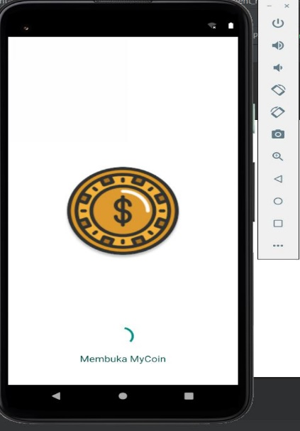

**Gambar 3. 1 Tampilan splash screen program**

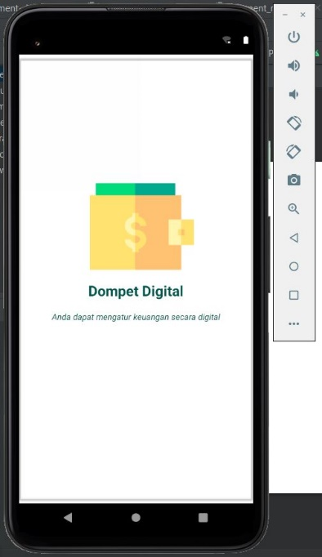

**Gambar 3. 2 Tampilan pengenalan aplikasi**

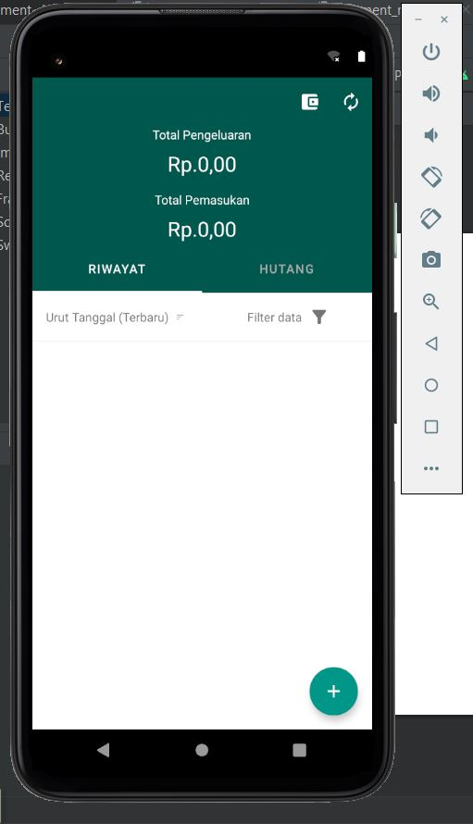

**Gambar 3. 3 Tampilan utama halaman riwayat**

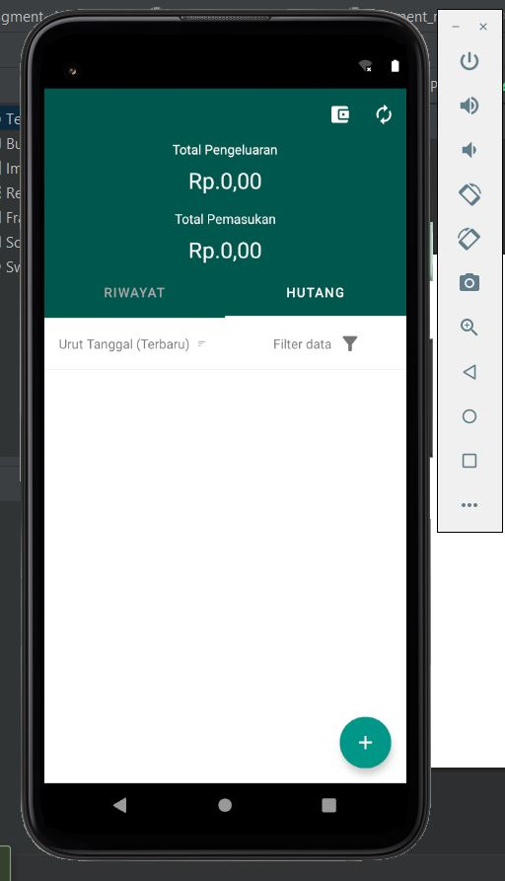

**Gambar 3. 4 Tampilan utama halaman hutang**

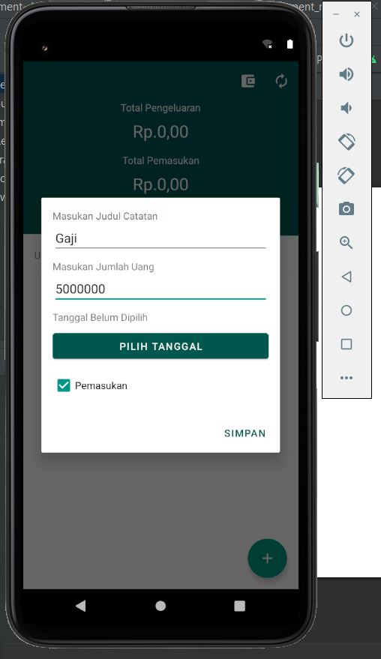

**Gambar 3. 5 Tampilan tambah catatan pemasukan halaman riwayat**

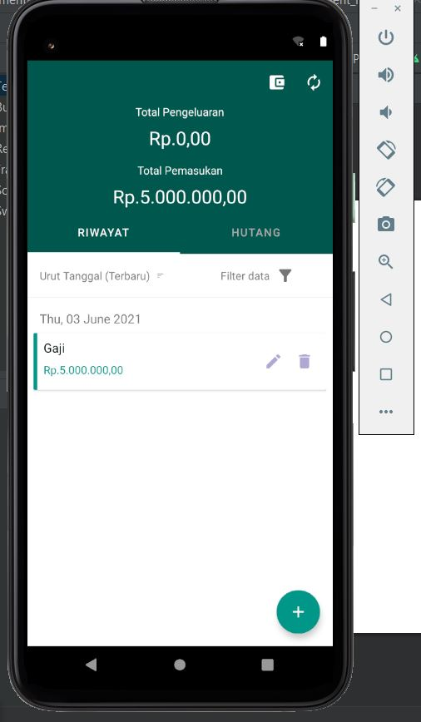

**Gambar 3. 6 Tampilan setelah klik simpan**

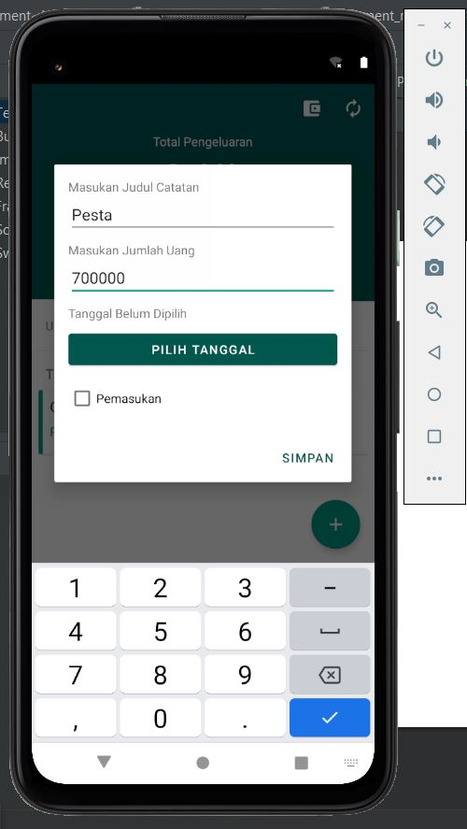

**Gambar 3. 7 Tampilan tambah catatan pengeluaran halaman hutang**

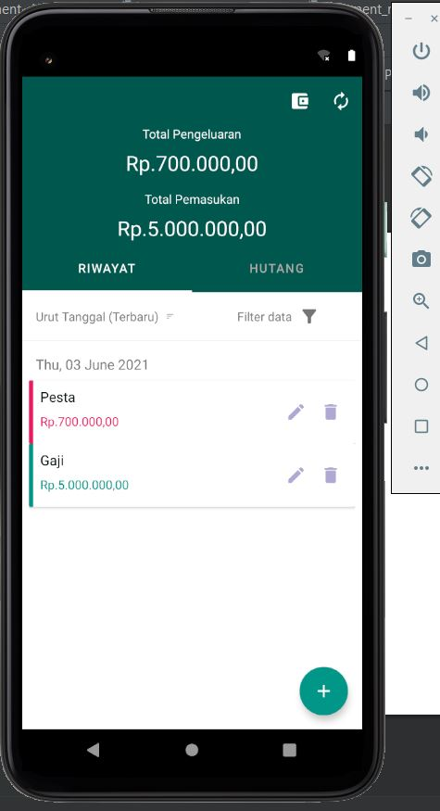

**Gambar 3. 8 Tampilan setelah klik simpan**

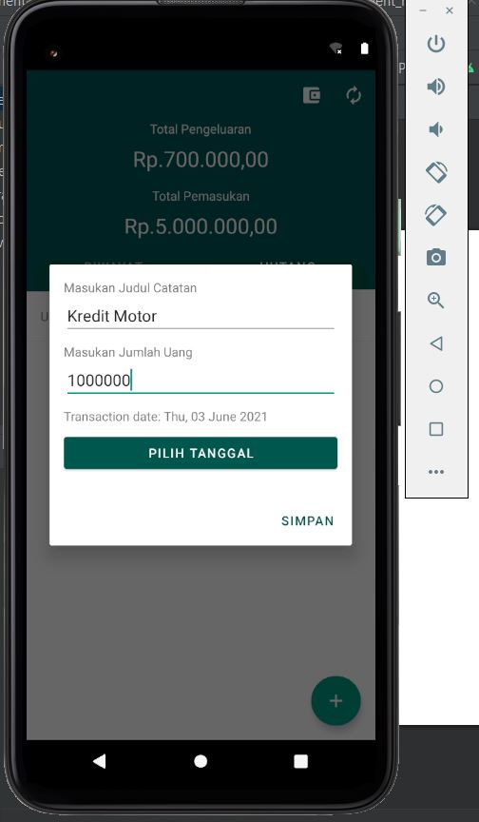

**Gambar 3. 9 Tampilan tambah catatan hutang**

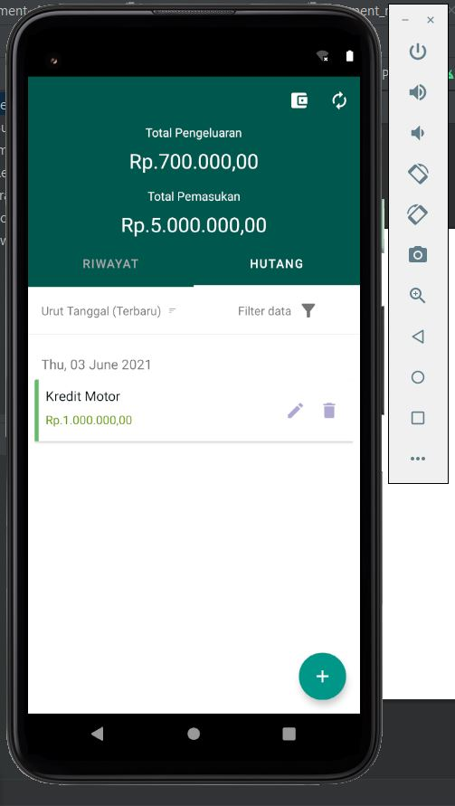

**Gambar 3. 10 Tampilan setelah klik simpan**

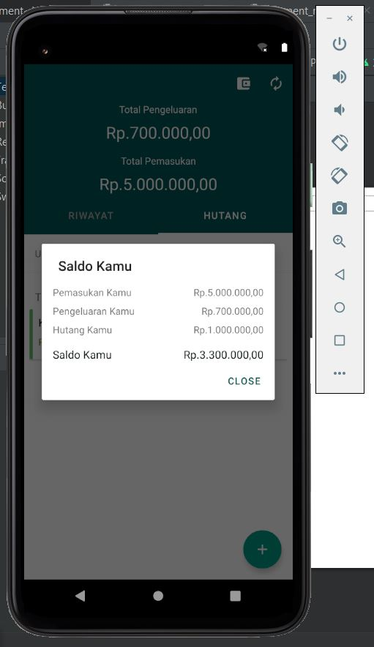

**Gambar 3. 11 Tampilan setelah klik report**

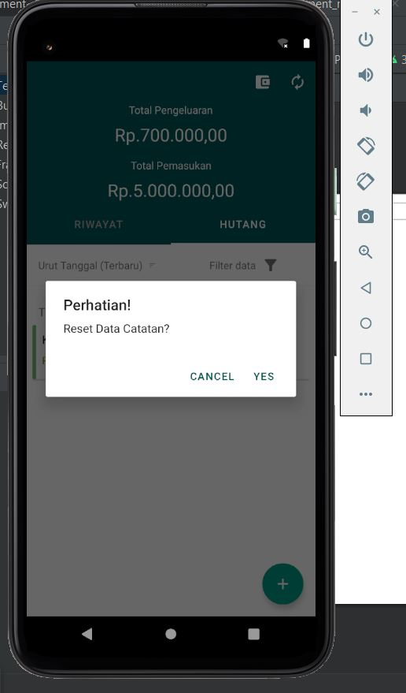

**Gambar 3. 12 Tampilan setelah klik reset**

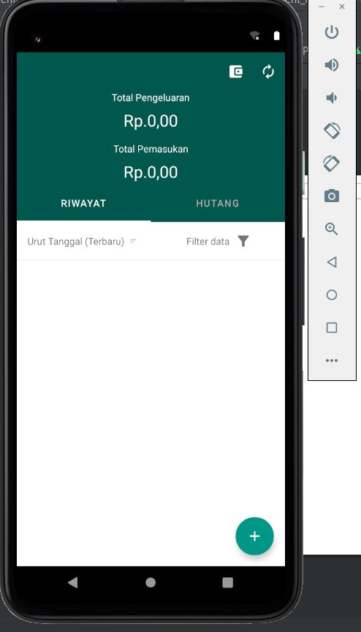

**Gambar 3. 13 Tampilan setelah klik yes**

### 3. Debuging

## BAB IV

## KESIMPULAN DAN SARAN

### 4. Kesimpulan

Aplikasi ini merupakan aplikasi pencatatan keuangan mandiri dimana user dapat mengatur pemasukan dan pengeluaran yang dapat dicatat secara non fisik di smartphone dimana saja dan kapan saja. Aplikasi ini berisikan Riwayat pendapatan dan pengeluaran serta waktu aktivitasnya.

### 4. Saran

Bisa di konfigurasikan dengan aplikasi pembayaran online seperti dana, link dan lain-lain